##### **IMDB Movie Analysis**

**Project Description**

• Dataset having 28 columns, 5044 Rows of different IMDB Movies.

• Defined a problem, clean the data as necessary remove null and duplicate values.

• Explore the data set and derive insights

• Use root cause analysis Five 'Whys' approach.

• Create chart pivot table and graphs to answer given questions

• Give answer to asked questions and create reports for data-driven decision

**Approach**

• Download and Data open in excel

• Find null and duplicate values and clean all data

• Data processing and solved as per asked problems.

• Use filter, pivot table, sum if, average if, count if and other functions to give answer of asked questions.

• Create charts to for easy and meaningful data representation

• Create report in ppt format and submit the project

**Tech-Stack Used**

1. MY SQL
2. GOOGLE DRIVE
3. MY EXCEL
4. MY WORD

**Insights and results**

**• 1. Clean the data-**

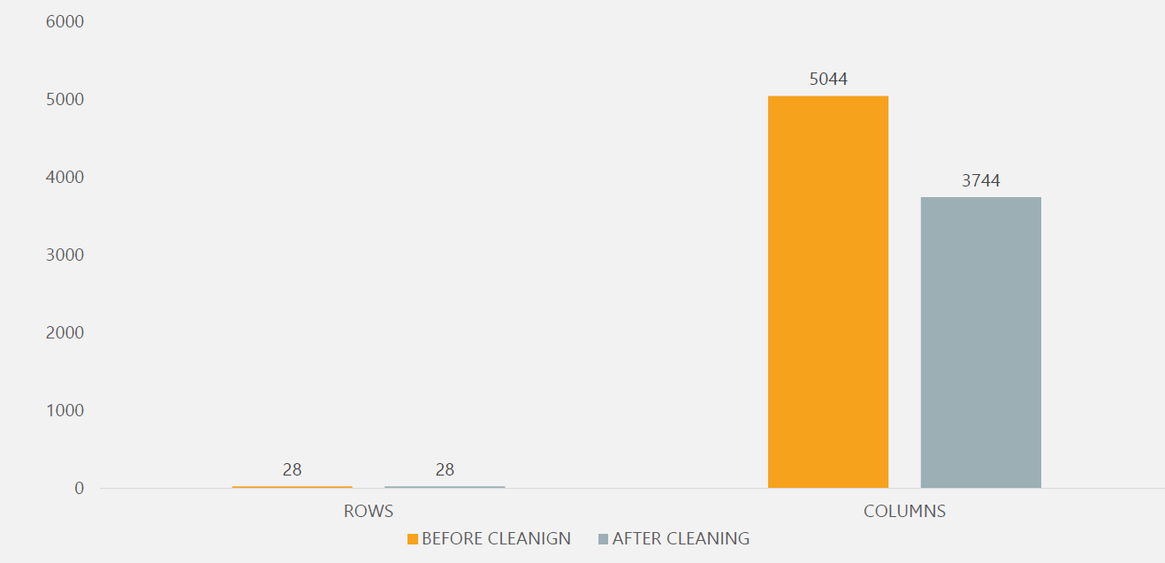

**2.Find the movies with the highest profit?**

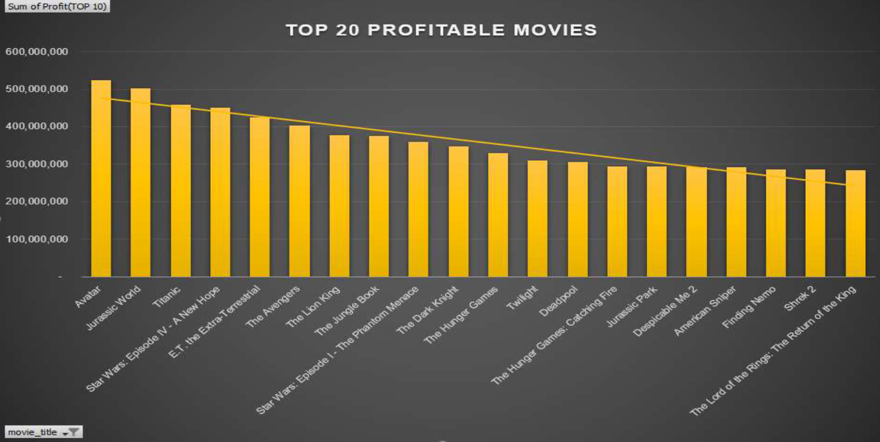

**3.Find IMDB Top 20.**

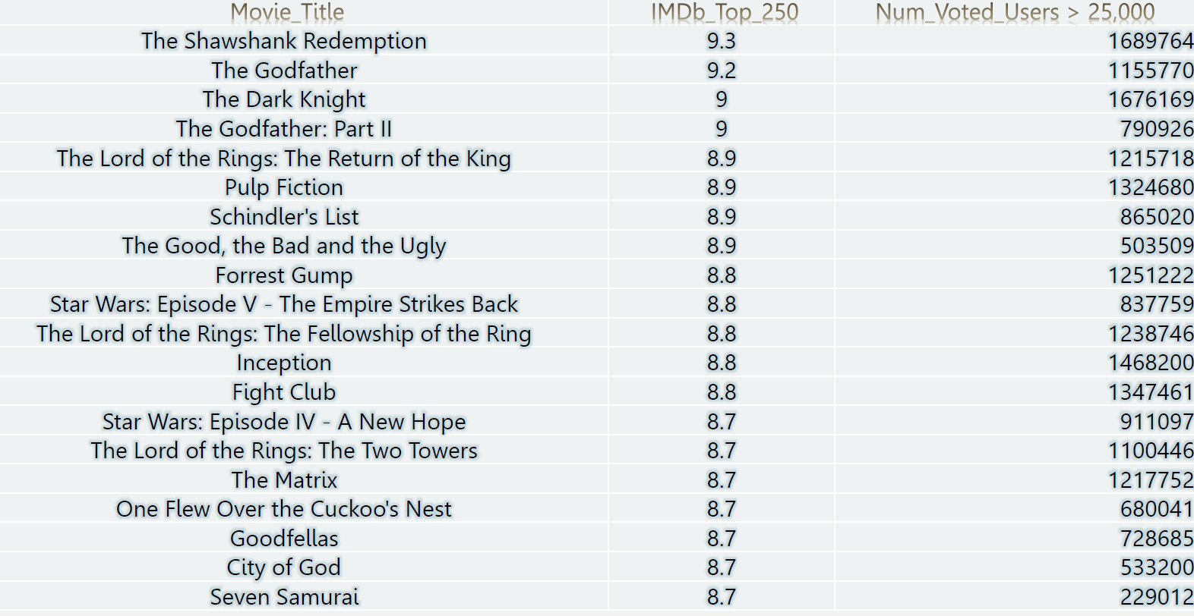

**4.Find the best directors**

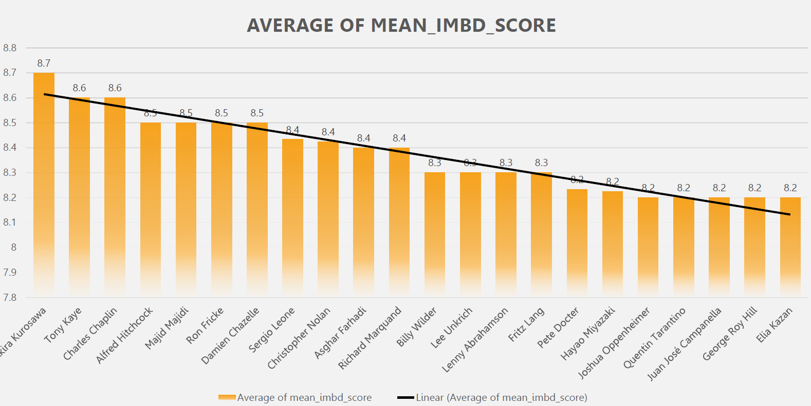

**5.Find popular genres**

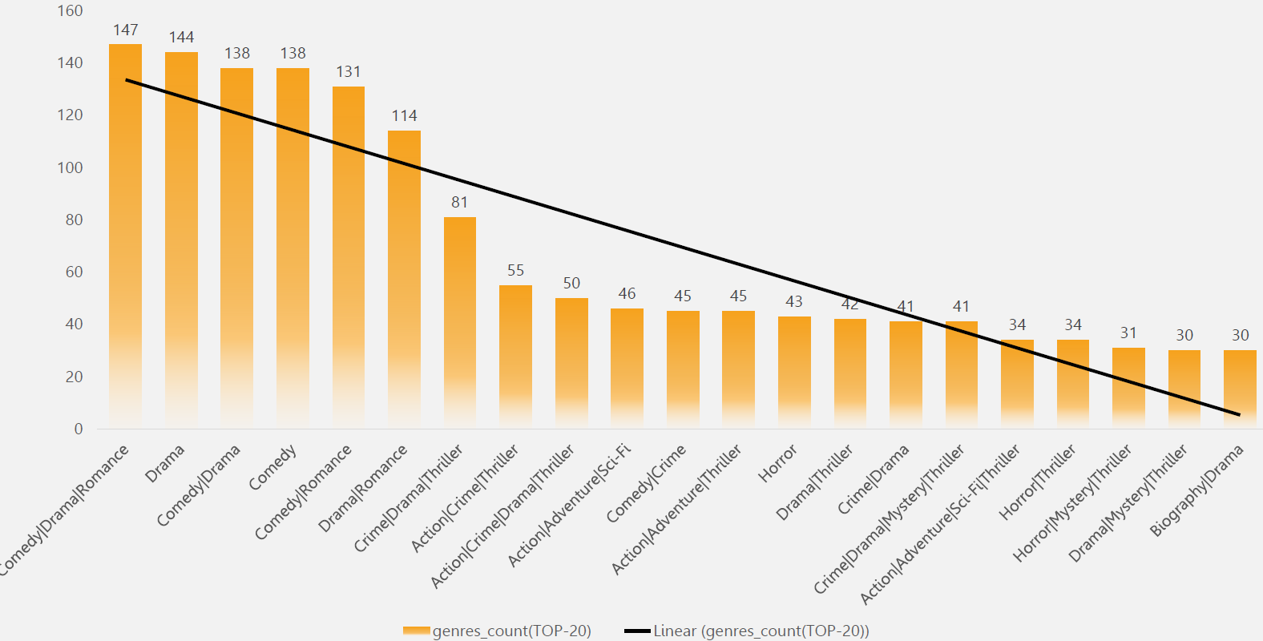

**6.Find the critic-favorite and audience-favorite actors**

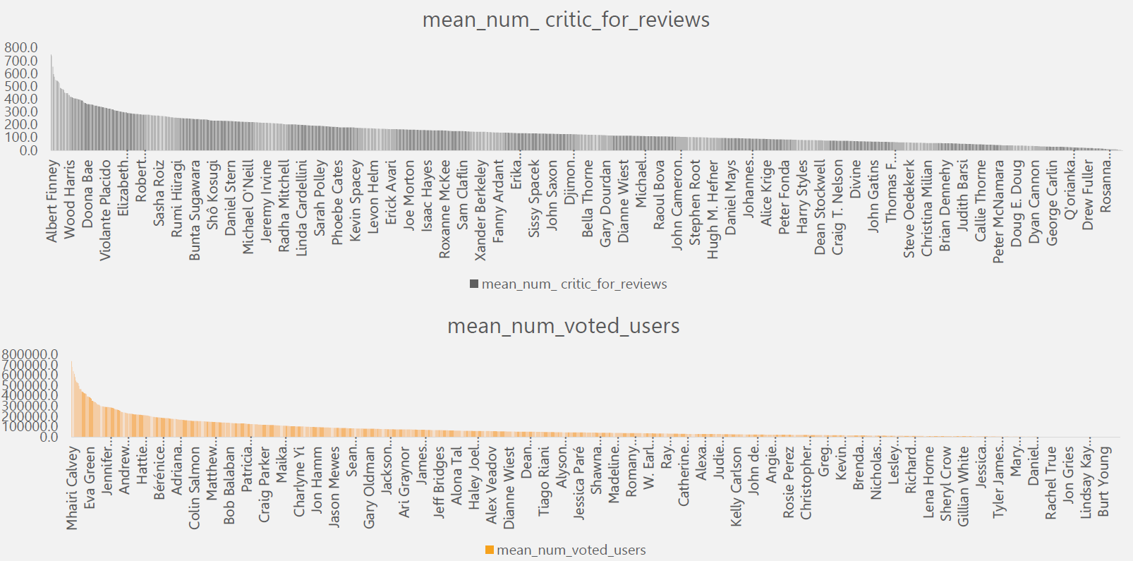

**\*\*SUM OF NUM_VOTED_USERS DECADE WISE**

